**Activity# 1**

Ofilada,Rod Samuel F.

Dao-Ayan Jona Mae

Lee,Alliyah

Casorog,Angelo Arteo

**Overview Codes:**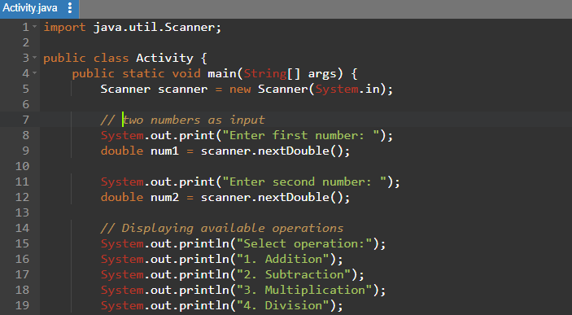

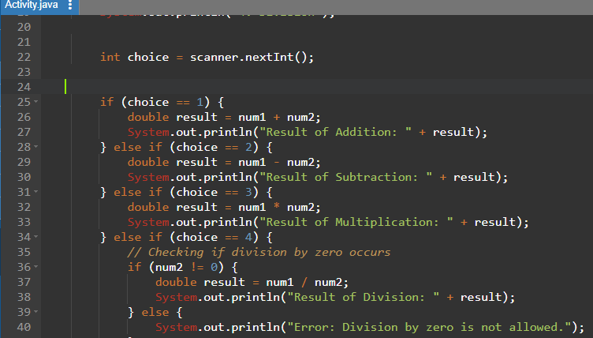

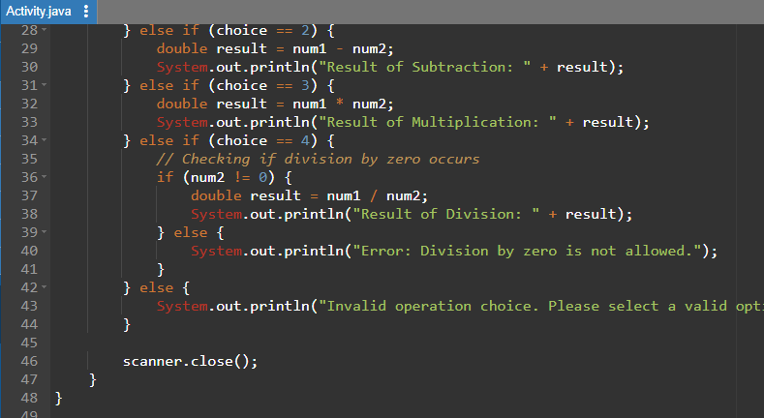

**Output:**

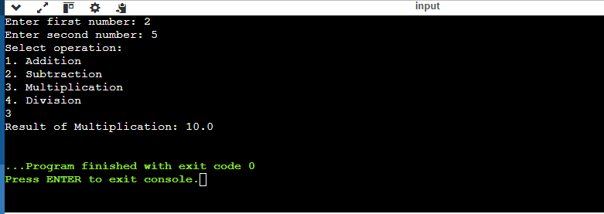

**Raw Codes:**

import java.util.Scanner;

public class Activity {

public static void main(String[] args) {

Scanner scanner = new Scanner(System.in);

// two numbers as input

System.out.print("Enter first number: ");

double num1 = scanner.nextDouble();

System.out.print("Enter second number: ");

double num2 = scanner.nextDouble();

// Displaying available operations

System.out.println("Select operation:");

System.out.println("1. Addition");

System.out.println("2. Subtraction");

System.out.println("3. Multiplication");

System.out.println("4. Division");

int choice = scanner.nextInt();

if (choice == 1) {

double result = num1 + num2;

System.out.println("Result of Addition: " + result);

} else if (choice == 2) {

double result = num1 - num2;

System.out.println("Result of Subtraction: " + result);

} else if (choice == 3) {

double result = num1 * num2;

System.out.println("Result of Multiplication: " + result);

} else if (choice == 4) {

// Checking if division by zero occurs

if (num2 != 0) {

double result = num1 / num2;

System.out.println("Result of Division: " + result);

} else {

System.out.println("Error: Division by zero is not allowed.");

}

} else {

System.out.println("Invalid operation choice. Please select a valid option (1-4).");

}

scanner.close();

}

}